MNIST Handwritten Digit Classiﬁcation

Abstract: Accurate handwriting recognition has been a challenging computer vision problem, because static feature analysis of the text pictures is often inade-quate to account for high variance in handwriting styles across people and poor image quality of the handwritten text. Recently, by introducing machine learning, especially convolutional neural networks (CNNs), the recognition accuracy of various handwriting patterns is steadily improved. In this paper, a deep CNN model is developed to further improve the recognition rate of the MNIST hand-written digit dataset with a fast-converging rate in training. The proposed model comes with a multi-layer deep arrange structure, including 3 convolution and acti-vation layers for feature extraction and 2 fully connected layers (i.e., dense layers) for classiﬁcation. The model’s hyperparameters, such as the batch sizes, kernel sizes, batch normalization, activation function, and learning rate are optimized to enhance the recognition performance. The average classiﬁcation accuracy of the proposed methodology is found to reach 99.82% on the training dataset and 99.40% on the testing dataset, making it a nearly error-free system for MNIST recognition.

Keywords: MNIST dataset; deep learning; convolutional neural network; handwriting recognition

- Introduction
The Modiﬁed National Institute of Standards and Technology (MNIST) handwritten digit database, one of the most important areas of research in pattern recognition, has excellent research and practical value. Generally speaking, handwriting classiﬁcation techniques can be divided into either statistical feature-related methods or structural feature-related approaches [1–7]. The former is usually caused by features other than the beginning and end points, intersections, contours, and unevenness; whereas the latter is mostly due to the density and feature area of handwritten pointers, and it is easier to mitigate the impact of irregular writing. However, traditional image processing algorithms focusing on static feature analysis at pixel level meet tremendous difﬁculties in MNIST handwriting recognition due to the two primary causes: 1) the glyph information for Arabic numerals is scarce and may share common features over

different numbers; 2) the handwriting varies dramatically from person to person, and some features may only occur under very speciﬁc but rare scenarios. These challenges mandate the use of dynamic information, such as the coordinates of the stroke trajectory point [8–13]. In recent years, there is a growing interest in using prevailing machine learning (ML) techniques in handwriting classiﬁcation with outstanding performance and generalization capabilities. By combining aforementioned typewritten features with traditional classiﬁcation methods, such as k-Nearest Neighbor (k-NN) and histogram of dimensional gradient (HOG) features [5,11], statistical classiﬁcation model [14–18], support vector machine (SVM) [19–21] and clustering [22,23], the classiﬁcation and recognition accuracy has been tremendously promoted.
In comparison to these approaches that rely on manual feature extraction, convolutional neural network (CNN)-based deep learning (DL) architectures, which is also known as deep neural networks (DNNs), can automatically extract the implicit correlation within and amongst data to ﬁnd useful patterns [5,24–26]. DNNs can process both shallow and deep features of the data in a thorough manner to produce more abstract and higher-level features with stronger semantic information [27–32]. Additionally, they are easier to design, modularize, and modify for different applications. By replacing the fully linked layer section of CNNs by Gated Recurrent Units (GRU), Vantruong Nguyen merged CNNs and GRU and achieve a recognition accuracy of up to 99.21% [20]. Typically, in order to achieve a higher recognition rate, more complex algorithm is required, which demands more computational time and higher space usage. However, the increasing number of hidden layers in the DNN may degrade the network’s capacity for generalization. As a result, using CNNs to accomplish error-free MNIST recognition remains difﬁcult, and there really is no methodology which can reach a 100% classiﬁcation performance for distinct character traits.
This paper is organized as follows. The key CNN design method is introduced in Section 2, focusing on the design of feature extraction, classiﬁcation method, hyper-parameter optimization, over-ﬁtting prevention strategy, and model veriﬁcation strategy. The model structure design and optimization analysis, particularly the experimental results of model performance validation, are discussed in Section 3. Finally, the fourth part summarizes the paper.

- The Proposed Approach for MNIST Handwritten Digit Classiﬁcation
The core steps of CNN-based recognition model primarily include extraction, classiﬁcation yield, and backpropagation to alter parameters in the network. The overall algorithm design process is presented in Fig. 1, where training, validation and testing share the similar process, except for using different datasets and the trained parameters are ﬁxed during the validation and testing process. The validation samples are utilized for cross-validation at the end of each training epoch/iteration. In order to maximize CNN classiﬁcation accuracy and highlight extraction for MINST recognition, a multi-layer deep arrange structure is constructed upon Keras and/or Tensorﬂow, which includes three convolution and activation layers for feature extraction and two fully connected layers (i.e., dense layers) for classiﬁcation (Fig. 2). The optimization strategy of hyperparameters (e.g., batch sizes, kernel sizes, batch normalization, activation function, dropout rate, etc.) is illustrated afterwards to get the best performance from the model.
  - Deep Neural Network Design
CNNs rely on multiple convolutional layers and non-linear layers (e.g., activation layer) for feature extraction, and key features can be retained through feature reduction techniques (e.g., max pooling, etc.). Detail steps can be speciﬁed as follows: 1) convolution layers can be employed multiple times throughout the DNN; each convolution layer can be individually implemented by the Keras/Tensorﬂow built-in two-dimensional (2D) convolution function, with appropriate kernel size, stride steps, input and output channels; “Padding” is set to ‘SAME’ so that the output of the convolution function remains the same

size as the input; 2) initialize each neuron/kernel in each CNN layer with a weight matrix and a bias scalar; to avoid the vanishing gradient problem and break the symmetry of neurons, a truncated normal distribution with a standard deviation of 0.1 is employed to initialize the weight matrix; in addition, for sake of avoiding the “death” of the neuron node (i.e., the output is always 0), a small positive number (e.g., 0.1) needs to be used to initialize the bias term; 3) batch normalization may be exploited to regulate the convoluted results within a certain range, to facilitate the following Rectiﬁed Linear Unit (ReLU) as the activation function to extract the features; 4) max pooling and/or other data reduction techniques are optionally applied to reduce the data dimension and computational cost, as well as to retain the key features.
Training and validation process
Hyperparameter adjustment
No
Start
Randomly selected samples
Optimization achieved?
Yes
Performance evaluation
End
Testing process

Classification
Feature extraction
Randomly selected samples
Data Preprocessing
Outcome evaluation on validation dataset

Classification
Feature extraction
Data Preprocessing
Figure 1: The proposed DL-based data processing diagram
The output of the last convolutional layer includes the extracted features, which are ﬂattened into a one-dimensional tensor and then forwarded to two fully connected (i.e., dense) layers. A Softmax layer is connected after the last fully connected layer to predict the likelihood of each category for each sample. The class with the highest probability is chosen as the sample’s predicted category.
In this study, three convolution layers are exploited for feature extraction (Fig. 2). The ﬁrst layer is equipped with a kernel of 3 × 3 and a stride of (1, 1), while the other two use a kernel of 6 × 6 and a stride of (2, 2) for two main purposes: 1) speeding up the converging rate with larger kernel size in deeper layers, and 2) use larger stride as an alternative to the max pooling layer for data dimension reduction. After three convolution layers, each of which is accompanied with a batch normalization and an activation layer, a total number of 1568 features are extracted and fed to two dense layers for classiﬁcation. Finally, the output layer has 10 nodes for the 10 different number digit categories.
  - Model Hyperparameter Optimization Strategy
Once a CNN backbone architecture is established, detailed hyperparameters (e.g., batch size, learning rate, etc.) need to be tweaked to determine the best shape of this CNN model to ﬁt the training and validation dataset, with a hope of achieving the best performance (e.g., accuracy, loss, etc.) upon other general data of the same kind.
    - Batch Size Analysis and Selection Method
The training batch size frequently has a signiﬁcant impact on the training outcomes. Too small batch size results in long training time and even may generate severe gradient oscillations, which will make the models converge slowly or even impossible. In contrast, too large value may lure the model to converge to a local rather than a global optimal value. Consequently, it is challenging to get the ultimate ideal solution through training. Thus, by appropriately adjusting the batch size, it is possible to effectively increase memory utilization, increase the parallel efﬁciency of high-dimensional matrix multiplication, reduce training time and the likelihood of gradient oscillation, pushing the model convergence to the optimal results.

Empirically, the global batch size can be set as Batch_size = 128*Number of Accelerators (e.g., parallel network replicas); tf.data will automatically split the global batch size among all replicas.

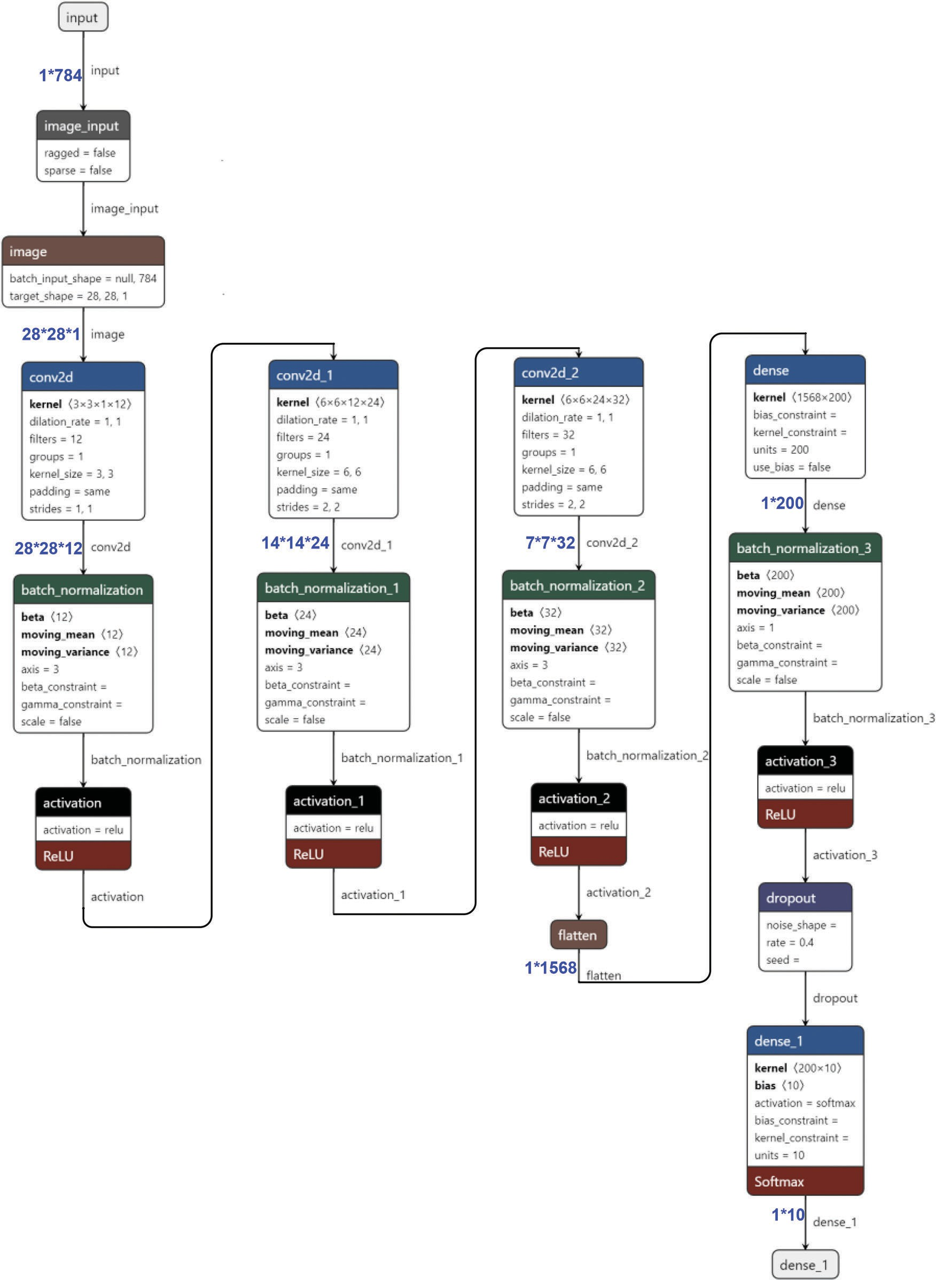
Figure 2: The architecture of the designed CNN model

    - Learning Rate Decay Technique
When an alternative mini-batch gradient descent method is available for training because of the intriguing project’s noise, employing a ﬁxed learning rate leads the error to decline and evolves toward the local minimum, but may eventually oscillate around rather than truly converges at the global optimal point. Thus, the learning rate should be gradually decreased throughout the training process to minimize this problem. The research uses the attenuation of learning rate to strike a compromise between rapid convergence and stability. A relatively large initial training step size can be utilized to speed up the training convergence at early stage, and then it is gradually decreased to approach the global optimum, or swing back and forth in the vicinity of the optimum, as the strategic alignment and hidden layers are intensiﬁed to improve the training accuracy at convergence. This prevents gradient descent from falling into local minimum values or even gradient divergence.
    - Techniques to Prevent Overﬁtting
Generally speaking, deep learning networks are susceptible to overﬁtting problems: the model’s performance on both the training and validation datasets improves over the training iterations, but drops on the validation dataset after a certain number of iterations while it continues to rise on the training dataset. This indicates that the model ﬁts the training sample too closely, limiting its generalizability. In addition, encoding sample labels (e.g., one-hot encoding) may unnecessarily increase the difference between the full probability and zero probability categories, causing the prediction model to rely excessively on the predicted category, thereby increasing the likelihood of overﬁtting.
Common approaches to ameliorate this issue includes 1) reasonable data ﬁtting and 2) using one or more “Dropout” layers to nullify a random portion of the trained parameters in the CNN after each training epoch. This work analyzes the incorrect predictions on the dataset to avoid overﬁtting and achieve the highest classiﬁcation accuracy. Whenever the model’s performance on the validation set begins to deteriorate during the training process, the model’s training is interrupted and the trained parameters are preserved to avoid the overﬁtting induced by excessive training. By doing so, a model with the minimum validation loss and potentially better test outcomes can be achieved. In this study, if the validation loss stops dropping and starts to converge or increase in two consecutive training epochs, the training process should be stopped, and the epoch when the local validation loss is the lowest, or validation accuracy is the highest, must be noted to ease the process of reloading model parameters for model deployment.
    - In Model Validation and Evaluation
order to evaluate the built model, the cross-entropy, Eq. (1), is employed as the COST function to quantify the loss of the model outcomes. The index is minimized over the training process to improve the recognition ability of the model.

H_{y}0 ðyÞ¼ - X

i2^
y⁰ logðy_{i}Þ (1)

where y and y⁰ are the classiﬁcations of model prediction and the real classiﬁcations (i.e., ground truths or labels) of samples respectively, and i 2^ is the sample indicator corresponding to the dataset. The accuracy rate and losses are calculated separately for each category, and these two indicators could
i
describe the efﬁcacy of the proposed model more comprehensively.

- Experiments
  - MNIST Handwritten Digit Dataset
MNIST database is one of the foremost classical imaging datasets within the ﬁeld of machine learning, and is broadly utilized for benchmarking in image classiﬁcation. The MNIST database contains

60,000 training samples and 10,000 testing samples (Table 1), each consisting of a 28*28 pixel grayscale image of a handwritten Arabic digit. The number sample in each image is normalized/standardized and centered. The 60,000 training samples are further divided into 55,000 training dataset and 5,000 validation dataset.

Table 1: MNIST dataset

Dataset object Sample amount Role Data_sets.train 55,000 Training dataset
Data_sets.validation 5,000 Validation dataset
Data_sets.test 10,000 Testing dataset

  - Model Hyperparameter Optimization
- Placeholder and parameter setting.
A placeholder is created for each input image and its label: X represents the one-dimensional (1*784) vector associated with a 28*28 image, and Y represents the corresponding label (i.e., the ground truth of classiﬁcation). Subsequently, the one-dimensional image vector is transformed into a two-dimensional matrix, i.e., the image data vector of 1*784 is converted into the original structure of 28*28. Since the MNIST is a grayscale image dataset, the color channel for each image is 1 (3 for RGB images). For training and testing with different numbers of images, the conversion number is set to −1, indicating an indeﬁnite number, for automatic matching of the number of images.
- The design of convolutional layer and activation layer.
In the ﬁrst layer, the size of the convolution kernel is set to be 3 × 3, and the weight and bias terms are initialized. The output channel is 12 to extract 12 different features. Then, the inner product of the convolution kernel and the input is computed, and the bias term is added to the convolution result. A batch normalization layer is employed to regulate the convolution results, followed by an ReLU activation function/layer for non-linear processing and feature extraction. The second layer is also a combination of convolution, batch normalization and activation functions, but with a kernel size of 6*6 and a stride of (2, 2) in the convolution layer, which reduces the image tensor size to a half, i.e., 14*14. In addition, the number of features is increased to 24. The third layer is similar to the second in kernel size and stride, but is extended to 32 features in total. In the end, the output of the third layer is ﬂattened to a 1* (7*7*32) = 1*1568 tensor, fed to the following fully connected layers for classiﬁcations.
- Fully connected layers and dropout layer for classiﬁcation and overﬁtting reduction.
The ﬁrst fully connected layer has 200 hidden nodes, and an ReLU activation function is applied afterwards to make the input with bias terms have nonlinear characteristics. The Dropout is employed during training to randomly discard 40% of the trained neurons (i.e., weights and biases) to reduce overﬁtting. The output of the second dense layer is connected to the Softmax classiﬁer to obtain the probability of each category of classiﬁcation, and the class with the highest probability is selected as the predicted class of the corresponding sample. When the neural network model is validated, all nodes are retained to obtain the best predictive classiﬁcation performance.
  - Learning Rate Attenuation and Classiﬁcation Analysis
As aforementioned that a variable learning rate should be considered to achieve the optimum training outcomes, in this paper, exponential decay is used as the learning rate decay method. The initial learning

rate is set at 0.001 and the learning rate decay factor is set at 0.99. As a result, the recognition accuracy of the model has been signiﬁcantly improved by 2.9% on the test set, while the loss has been drastically reduced. The improvements in accuracy of various numbers/classes are also observed. This shows that the learning rate decay can effectively improve the recognition accuracy of the MNIST handwritten dataset.
  - Model Optimization and Performance Evaluation
By deﬁning the cross-entropy loss function and a small value of the initial learning rate (i.e., 1*10⁻³), the Adam optimizer is used to automatically to minimize the loss function during the training process. In this process, the loss will be backpropagated to adjust the network parameters to better ﬁt the training sample data. Here, the batch size is set to 1000, which means 1000 training samples are sent to the model for training with random gradient descent. The proper batch size can reduce computational overhead while generalize the overall characteristics of the dataset. The dropout rate is set to 0.4. One can see that the training loss and accuracy converge within 10 iterations (Table 2) and each iteration uses 5000 validation samples for cross-validation (Table 1 and Fig. 3). Some of the predicted digit with recognition rate are shown in Fig. 4. Over the training process, the model’s classiﬁcation accuracy improves, the loss decreases, yet the best validation performance is achieved at Epoch 8 (Fig. 3). Visualization of the training and validation dataset is provided in Fig. 5, and some of the validation digits with incorrect predictions are provided in Fig. 6.

Table 2: Model training accuracy, loss and learning rate

Epoch | Training accuracy | Training loss | Learning rate
1 | 0.9598 | 0.1311 | 1.00e-02
2 | 0.9874 | 0.0400 | 5.01e-03
3 | 0.9927 | 0.0238 | 2.52e-03
4 | 0.9950 | 0.0153 | 1.20e-03
5 | 0.9966 | 0.0115 | 6.25e-04
6 | 0.9975 | 0.0090 | 3.12e-04
7 | 0.9980 | 0.0078 | 1.56e-04
8 | 0.9982 | 0.0072 | 7.81e-05
9 | 0.9981 | 0.0068 | 3.90e-05
10 | 0.9939 | 0.0070 | 1.95e-05

The testing dataset is ﬁnally examined to verify the entire training and validation process, and achieve an accuracy of 99.40% and loss of 0.0171. The performance of the model on the test set resembles the training results. On the other hand, the accuracy rates vary on different digits. For example, 97% of number “6” are correctly classiﬁed while “1” reaches 100%. Fig. 7 displays ﬁgures that are challenging to recognize correctly. Additionally, the convolution kernels provide the feature set of the input pictures, and they can be used to visualize the characteristics of the input images. However, there is currently no efﬁcient analysis method for thoroughly evaluating and modelling the signiﬁcance of each neuron in convolutional layers because it contains lots of high-dimensional elements which are difﬁcult to comprehend intuitively. Nevertheless, assessing the features extracted by each convolution kernel by analyzing the model with a larger sample and displaying the output of each layer is still beneﬁcial. The classiﬁcation accuracy of the proposed structure is compared with other state-of-the-art models (Table 3), and has demonstrated signiﬁcant improvement in classiﬁcation accuracy.

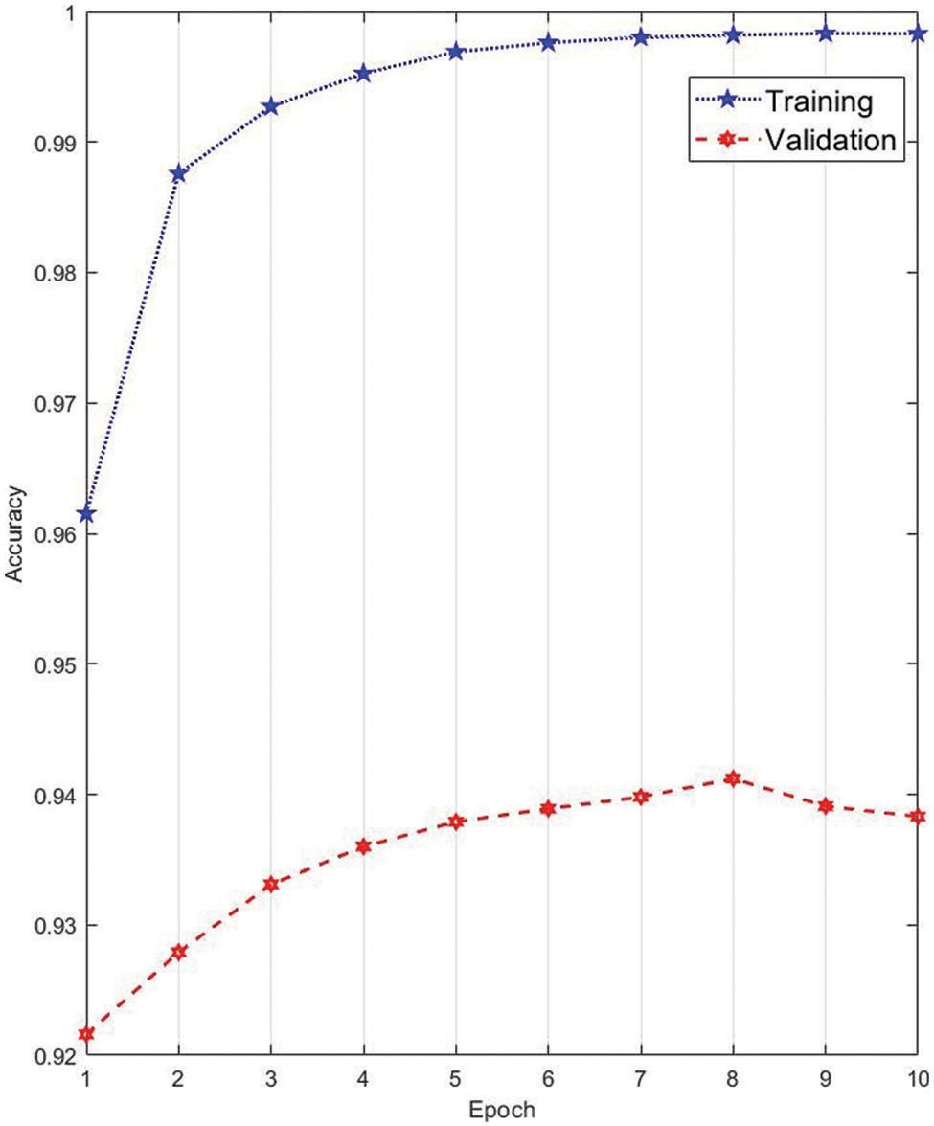
Figure 3: Training and validation accuracies
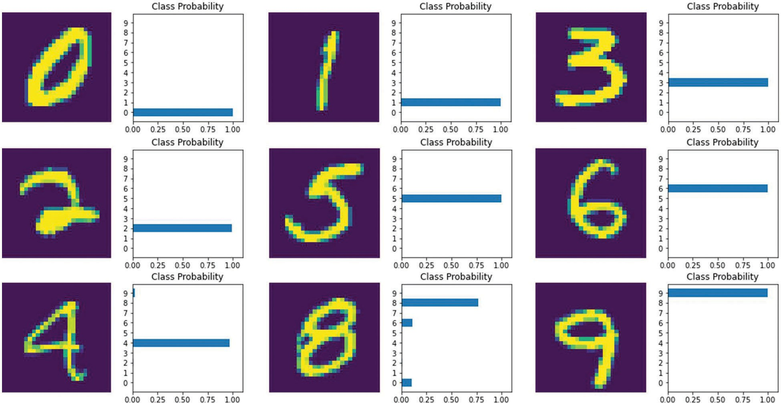
Figure 4: Some of the predicted digit with recognition rate

Figure 5: Visualization of the training and validation dataset
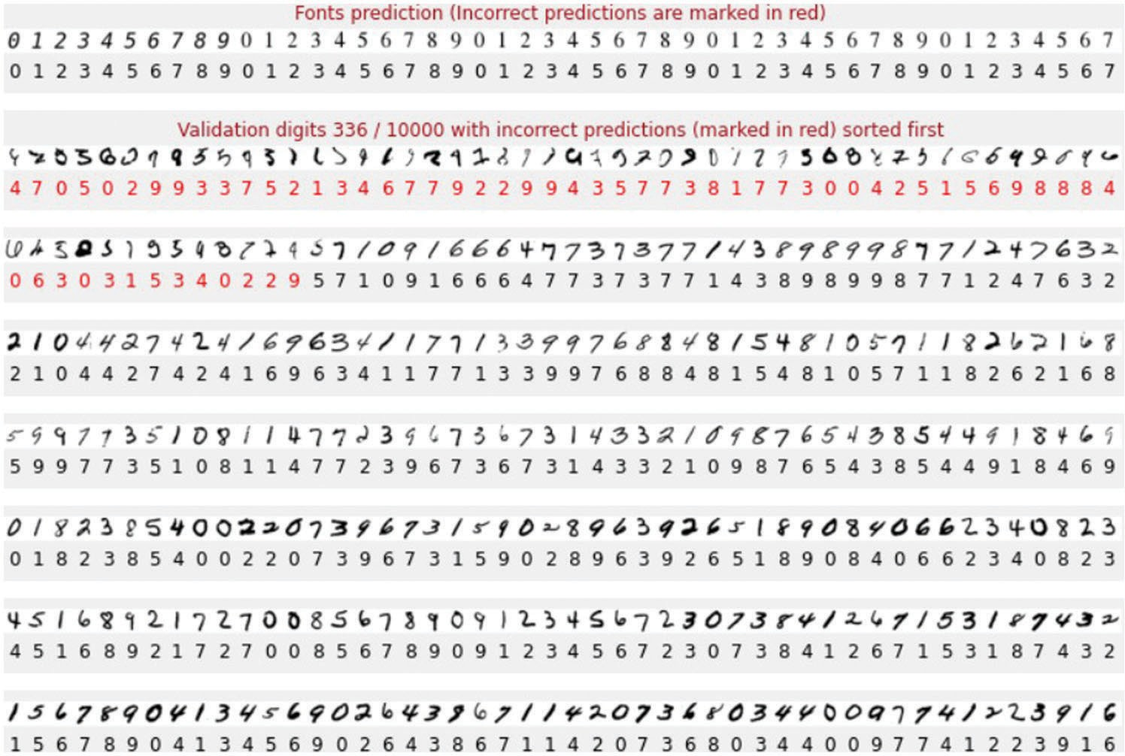
Figure 6: Some of the validation digits with incorrect predictions
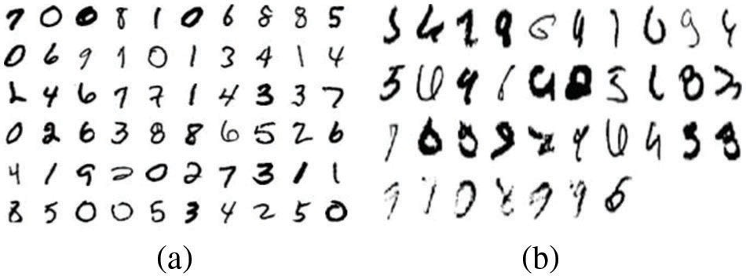
Figure 7: (a) Numbers with high recognition rates; (b) Numbers with low recognition rates
Table 3: Comparison with the benchmark approaches

Methods | Train. acc. | Train. loss | Val. acc. | Val. loss | Test. acc. | Test. loss
Googlenet [33] | 0.98 | 0.0064 | 0.97 | 0.0029 | 0.98 | 0.0014
InceptionV3 [34] | 0.95 | 0.0020 | 0.95 | 0.0042 | 0.96 | 0.0013
Xception [35] | 0.96 | 0.0035 | 0.96 | 0.0141 | 0.96 | 0.0019
VGG16 [36] | 0.96 | 0.0065 | 0.97 | 0.0391 | 0.97 | 0.0024
Basic CNNs | 0.98 | 0.0237 | 0.97 | 0.0578 | 0.98 | 0.0901
Proposed | 0.99 | 0.0260 | 0.99 | 0.0174 | 0.99 | 0.0136

- Conclusions
This study elaborates the details of developing a light-weight DNN for handwriting digital recognition/ classiﬁcation using the MNIST dataset. The CNN-based backbone architecture and the methodology of numerous hyperparameter optimizations, including batch size, learning rate, etc., are explored in detail to enhance the training and testing outcomes. The developed neural network model is evaluated upon Keras/ Tensorﬂow framework, and the overall accuracy of the developed model can reach 99.4% on the MNIST dataset, compatible with the results from other state-of-the-art models.

